Name_____________________ SO_________________________

Instructions. Identify the choice that best completes the statement or answers the question. Each question is worth 1 point.

- The data collected by your group has sampling error, which…
  - is greater in large samples compared to small samples
  - should be as large as possible
  - is eliminated by using probability samples
  - reflects differences between the sample and population

- Which of the following is an example of a nondirectional hypothesis?
  - I hypothesize there is a positive relationship between a high-fat diet and weight gain.
  - I hypothesize there is a negative relationship between a high-fat diet and weight gain.
  - I hypothesize there is a relationship between a high-fat diet and weight gain.
  - I hypothesize there is no relationship between a high-fat diet and weight gain.

- “I hypothesize there is no difference in the weight between rats fed low-fiber diets and rats fed high fiber diets,” is an example of a(n)_________________.
  - Null hypothesis
  - Alternative hypothesis
  - Directional hypothesis
  - Nondirectional hypothesis

Scenario. Jennifer conducts a study to determine if a new intervention is effective at reducing drug relapse.
Independent variable = New intervention vs. Old intervention
Dependent variable = Whether or not the individual relapses

Answer questions #10 to #16 by applying Jennifer’s study to the concepts such as: Type I errors, Type II errors, hypotheses, etc.

- If Jennifer finds a statistically significant effect (her new intervention is better at reducing relapse than the old intervention), but in reality, the effect does not truly exist in the population (her new intervention is not better). This is a:
- Type I error
- Type II error
- Correct decision
- Error in power

- Jennifer does not find a statistically significant effect, but in reality, the effect does truly exist in the population. This is a:
- Type I error
- Type II error
- Correct decision
- Error in power

- If Jennifer does not find a statistically significant effect, but in reality, the effect does truly exist in the population, what is the most likely reason why she did not find the effect?
- The presence of outliers
- The sample was 2 standard deviations above the mean
- She did not have a large enough sample size
- Because she used a stratified sampling procedure

- What percentage of risk are researchers usually willing to take that they will find a statistically significant effect, but the effect does not truly exist in the population?
- 2%
- 5%
- 10%
- 0%

- Jennifer needs your help. In technical terms, if Jennifer does not find an effect, does she:
- Fail to reject the null hypothesis
- Accept the alternative hypothesis
- Reject the null hypothesis
- Error in power

- What is an example of Jennifer’s null hypothesis? Jennifer hypotheses that…
- the new intervention is significantly better than the old intervention at reducing relapse
- the old intervention is significantly better than the new intervention at reducing relapse
- there is not a statistically significant difference in the new intervention’s ability to reduce relapse when compared to the old intervention.
- there is a statistically significant difference between the new intervention and the old intervention and reduction of relapse

- In inferential statistics, which of the following hypotheses are we directly testing? Jennifer hypotheses that…
- the new intervention is significantly better than the old intervention at reducing relapse
- the old intervention is significantly better than the new intervention at reducing relapse
- there is not a statistically significant difference in the new intervention’s ability to reduce relapse when compared to the old intervention.
- there is a statistically significant difference between the new intervention and the old intervention and reduction of relapse

Instructions. Identify the choice that best completes the statement or answers the question.

- What is the basis for the normal curve?
  - Mean
  - Asymptotic
  - Probability
  - Symmetry

- What is the foundation of inferential statistics?
  - Probability
  - Linear algebra
  - Mathematical proofs
  - Algebra

- What type of standard score has M = 0 and SD = 1?
  - IQ score
  - T score
  - x score
  - z score

- If you want to calculate a z score for a test where your raw score was 24, what other information must you know?
  - Shape of the distribution
  - Mean, median, and mode
  - Mean and standard deviation
  - Standard deviation only

- Which of the following is true of z scores that fall below the mean?
  - They are positive
  - They are equal to the mode
  - They are negative
  - They are in the upper half of the distribution

- What are true of z scores which are equal to the mean?
  - They are negative
  - They are positive
  - They are equal to zero
  - They are equal to one

- What is the standard used by statisticians to determine the probability of an event occurring outside of chance alone?
  - .05%
  - 5%
  - 95%
  - 99%

- Events that occur in the extremes of the normal curve have a very small probability of occurring.
  - True
  - False

- By using z-scores, one could compare one student’s results on the ACT with another student’s results on the SAT.
  - True
  - False

- Which of the following terms are associated with identifying differences between groups that are not due to chance?
  - Probability
  - Meaningfulness
  - Statistical significance
  - Statistics

- There is always the possibility of error in statistics because the __________ is not directly tested.
  - Population
  - Sample
  - Significance
  - Probability

- The ________ is tested, and the results are generalized to the __________.
  - Sample, larger population
  - Sample, smaller population
  - Population, smaller sample
  - Population, larger sample

- The degree of risk you are willing to take that you will reject the null hypothesis when it is actually true is called ____________.
  - Significance level
  - Type II error
  - Type II error
  - Power

- A(n) ____________ difference is due to some systematic influence and not due to chance.
  - Significant
  - Insignificant
  - Null
  - Serendipitous

- Some statistical tests allow you to make a conclusion that there is a real effect with 100% certainty.
  - True
  - False

Scenario. With the onset of COVID-19, university students had to make a lot of adjustments in their social and academic lives. As a result, many students reported feeling dissatisfied with a mostly online educational experience. A team of faculty members at SEMO wondered whether students who were required to have weekly face-to-face meetings with their professors via Zoom would be more satisfied with online courses than students who were not required to have the meetings. The faculty members randomly assigned 30 students to one of two conditions. In the control condition (Group 1), 15 students took part in an asynchronous online course that did not require live meetings with the professor. In the experimental condition (Group 2), 15 students took part in the same online course, but were required to have weekly Zoom meetings with the professor (Group 2). At the end of the semester, the students from both groups rated their satisfaction with the course on a scale of 1 (Not at all satisfied) to 25 (Extremely satisfied). Use the SPSS output below to determine whether weekly Zoom meetings with the professor resulted in higher levels of student satisfaction.

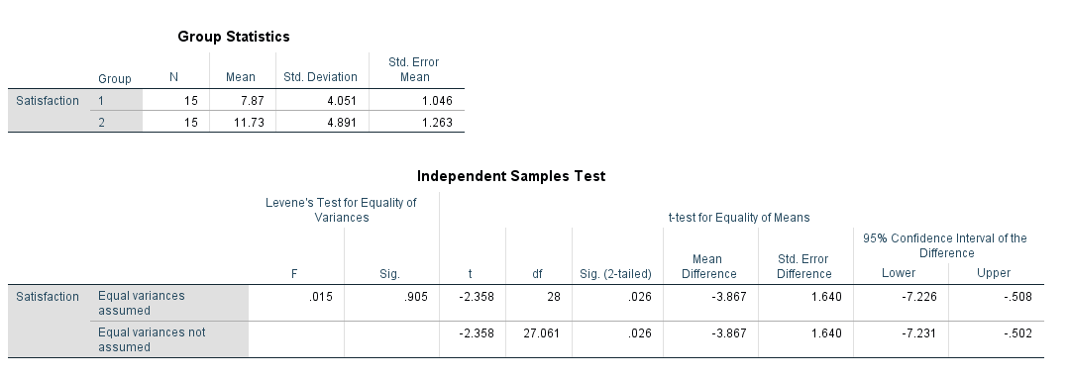

- What type of statistical test is most appropriate given this research question?
- Correlation
- Independent samples t-test
- Dependent samples t-test
- Z-test

- What is the independent variable?
- Before and after the online class
- Satisfaction
- Online class with or without weekly Zoom meetings
- The faculty members

- What is the dependent variable?
- Before and after the online class
- Satisfaction
- Online class with or without weekly Zoom meetings
- The faculty members
- What is the null hypothesis?
- Student satisfaction improves with weekly Zoom meetings.
- Student satisfaction decreases with weekly Zoom meetings.
- There is no difference in student satisfaction with or without weekly Zoom meetings.
- There is a difference in student satisfaction with or without weekly Zoom meetings.

- What is the directional alternative hypothesis?
- Student satisfaction improves with weekly Zoom meetings.
- Student satisfaction decreases with weekly Zoom meetings.
- There is no difference in student satisfaction with or without weekly Zoom meetings.
- There is a difference in student satisfaction with or without weekly Zoom meetings.

- What number represents the test statistic?
- 11.73
- -2.358
- -3.869
- 7.87

- Degrees of freedom(s)?
- 15
- 30
- 28
- 32

- What is the calculated probability that the null hypothesis is true?
- .508
- .026
- 1.64
- 2.35

- Is there a statistically significant difference?
- Yes
- No

- Which option below includes an interpretation of the results in plain language.
- There is a statistically significant difference in student satisfaction between students who had Zoom meetings and those who did not.
- There is not a statistically significant difference in student satisfaction between students who had Zoom meetings and those who did not.
- Student satisfaction was worse with weekly Zoom meetings.
- Student satisfaction was better with weekly Zoom meetings.

Directions. Please make sure your answers are on the exam. You can use additional sheets of paper to show your work calculations. Do not round any of the numbers and report numbers with two decimals. PLEASE WRITE NEATLY AND CLEARLY. All the equations and critical tables you need for the calculations below are in your materials.

Scenario. Many studies have found that animals can be therapeutic. Therefore, Blanchard Elementary School wants to determine if a 6-week animal therapy course will help improve the happiness of kids with posttraumatic stress disorder (PTSD). The school recruits 3 kids from the elementary school that have PTSD. The elementary school gives the 3 kids a survey on happiness before they participate in a 6-week animal therapy course and then the school gives the 3 kids the same survey after the 6-week animal therapy course. The happiness scale ranges from 1 to 100 with 1 being not happy at all and 100 being very happy. The school wants to know if the animal therapy course is effective at increasing levels of happiness.

 | Happiness score before the 6-  week animal therapy course | Happiness score after the 6-week animal  therapy course
1 | 10 | 30
2 | 30 | 45
3 | 25 | 40

- What type of statistical test is most appropriate given this research question?
- Correlation
- Independent samples t-test
- Dependent samples t-test
- ANOVA

- What is the independent variable?
- Posttraumatic stress disorder
- Happiness
- Before and after the 6-week animal therapy course
- Before and after they rate a happiness scale from 1 to 100

- What is the dependent variable?
- Posttraumatic stress disorder
- Happiness
- Before and after the 6-week animal therapy course
- Before and after they rate a happiness scale from 1 to 100

Use inferential statistics and calculate the test statistic. You must show ALL of your work below (and on the next page there is space) or show your work on a separate sheet of paper(s).

 | Happiness score before the 6-  week animal therapy course | Happiness score after the 6-week animal  therapy course | Difference (D) | Difference squared (D²)
1 | 10 | 30 | 20 | 400
2 | 30 | 45 | 15 | 225
3 | 25 | 40 | 15 | 225
 |  |  | ∑D=50 | ∑D²=900

Inferential Statics
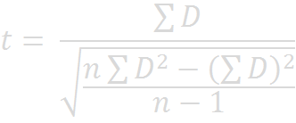

$$t=50/√\{\frac{2700-2500}{2}\}$$

$$t=\frac{50}{\sqrt{100}}$$

$$t=5$$
$$p=0.211$$

- What is the null hypothesis?
- Individuals’ happiness improves after completing the 6-week animal therapy course.
- Individuals’ happiness gets worse after completing the 6-week animal therapy course.
- There is no change in the individuals’ happiness before vs. after participating in the 6- week animal therapy course.
- There is a change in the individuals’ happiness before vs. after participating in the 6- week animal therapy course.

- What is the directional alternative hypothesis?
- Individuals’ happiness improves after completing the 6-week animal therapy course.
- Individuals’ happiness stays the same after completing the 6-week animal therapy course
- There is no change in the individuals’ happiness before vs. after participating in the 6- week animal therapy course.
- There is a change in the individuals’ happiness before vs. after participating in the 6- week animal therapy course.

- What number did you get for your test statistic?
- -2.00
- -19.01
- -10.00
- -4.32

- Degrees of freedom(s)?
- 1
- 2
- 3
- 4

- What is the critical value for a two-tailed, significance level of 0.05?
- 6.314
- 2.920
- 3.182
- 4.303

- Is there a statistically significant difference?
- Yes
- No

- Which option below includes an interpretation of the results in plain language.
- There is a statistically significant difference in the individuals’ happiness after they participated in a 6-week animal therapy course.
- There is not a statistically significant difference in the individual’s happiness after they participated in a 6-week animal therapy course.
- The individuals’ happiness got worse after participating in the 6-week animal therapy course.
- The individuals’ happiness got statistically significantly better after participating in the 6- week animal therapy course.

Answer the following for EASY POINTS:

46. What do you like about this class?

It calls for critical thinking and analysis skills. It has been really helpful
47. What do you dislike about this class?

48. Do you feel like you are actually learning the material?
Yes, I actually feel like I am the learning the material

49. Would you recommend my class to a friend?

Yes
50. Any other comments?
None

